NIBE 360 remote zWAVE CONTROL PARTS LIST rev A

|  |  |  |  |  |  |
| --- | --- | --- | --- | --- | --- |
| nr | Partno | description | Link | price | quantity |
| 1 | ZMEEZUNO | Z-uno Z-wave board for Arduino | <https://z-uno.z-wave.me/technical/> | [505 SEK](https://www.lohelectronics.se/dator-and-elektronik/dator/kreditkorts-dator/z-uno-z-wave-board-for-arduino) | 1 |
| 2 | 88860 | Kjell Academy Uno Rev. 3 Arduino | [Uno-rev-3 arduino](https://www.kjell.com/se/sortiment/el-verktyg/arduino/utvecklingskort/kjell-academy-uno-rev-3-arduino-kompatibelt-utvecklingskort-p88860) | [149 SEK](https://www.kjell.com/se/sortiment/el-verktyg/arduino/utvecklingskort/kjell-academy-uno-rev-3-arduino-kompatibelt-utvecklingskort-p88860) | 1 |
| 3 | VMA436 | Velleman 8 CHANNEL RELAY MODULE | <https://www.velleman.eu/products/view/?id=439228> | [300 SEK](https://www.kjell.com/se/sortiment/el-verktyg/utvecklingskit/arduino/moduler/relamodul-for-arduino-8x-p87034) | 1 |
| 4 | 87944 | Luxorparts Proto-shield for UNO R3 | <https://www.kjell.com/se/sortiment/el-verktyg/arduino/shields/luxorparts-proto-shield-for-uno-r3-p87944> | [149 SEK](https://www.kjell.com/se/sortiment/el-verktyg/arduino/shields/luxorparts-proto-shield-for-uno-r3-p87944) | 1 |
| 5 | 90793 | Luxorparts Connection cables male-male 65-pack | <https://www.kjell.com/se/sortiment/el-verktyg/arduino/tillbehor/luxorparts-kopplingskablar-hane-hane-65-pack-p90793> | [1,10 SEK/st](https://www.kjell.com/se/sortiment/el-verktyg/arduino/tillbehor/luxorparts-kopplingskablar-hane-hane-65-pack-p90793) | 7 |
| 6 | 87900 | Luxorparts separable cable 40-pol female-male | <https://www.kjell.com/se/sortiment/el-verktyg/arduino/tillbehor/luxorparts-delbar-kopplingskabel-40-pol-hane-hona-p87900> | [2 SEK/st](https://www.kjell.com/se/sortiment/el-verktyg/arduino/tillbehor/luxorparts-delbar-kopplingskabel-40-pol-hane-hona-p87900) | 7 |
| 7 | 90664 | Double sided prototyping board with soldering pads | <https://www.kjell.com/se/sortiment/el-verktyg/elektronik/monsterkort/experimentkort/luxorparts-experimentkort-60x80-mm-10-pack-p90664> | [100 SEK](https://www.kjell.com/se/sortiment/el-verktyg/elektronik/monsterkort/experimentkort/luxorparts-experimentkort-60x80-mm-10-pack-p90664) | 1 |
| 8 | 402328 | Normkapsling – box with 12 modules DIN rail | [https://www.jula.se/catalog/el-och-belysning/elinstallation/elcentraler/kapslingar/normkapsling-402328/#tab01](https://www.jula.se/catalog/el-och-belysning/elinstallation/elcentraler/kapslingar/normkapsling-402328/%23tab01) | [300 SEK](https://www.jula.se/catalog/el-och-belysning/elinstallation/elcentraler/kapslingar/normkapsling-402328/%23tab01) | 1 |
| 9 | 78185 | Mjuk UTP-nätverkskabel Cat. 6 Grå | <https://www.kjell.com/se/sortiment/dator-natverk/natverk/installationsmateriel/natverkskablar/installationskablar/mjuk-utp-natverkskabel-cat-6-gra-p78185> | [15 SEK/m](https://www.kjell.com/se/sortiment/dator-natverk/natverk/installationsmateriel/natverkskablar/installationskablar/mjuk-utp-natverkskabel-cat-6-gra-p78185) | 5 |
| 10 | 37725 | Cable ties150x3,6 mm 100-pack Black | <https://www.kjell.com/se/sortiment/dator-natverk/kablar-adaptrar/kabelhantering/buntband/buntband-150x3-6-mm-100-pack-svart-p37725> | [50 SEK](https://www.kjell.com/se/sortiment/dator-natverk/kablar-adaptrar/kabelhantering/buntband/buntband-150x3-6-mm-100-pack-svart-p37725) | 1 |
| 11 | 1883077 | Phoenix contact Printed-circuit board connector - ZEC 1,5/ 5-ST-5,0 C2 R1,5 - 1883077 | <https://www.phoenixcontact.com/online/portal/se/?uri=pxc-oc-itemdetail:pid=1883077&library=sesv&pcck=P-11-02-11&tab=1&selectedCategory=ALL> | [4,21 € = 43,15 SEK](https://www.mouser.se/ProductDetail/651-1883077) | 1 |
| 12 | 45120 | 1x1,5 mm² FQ wire black | <https://www.kjell.com/se/sortiment/el-verktyg/el-produkter/starkstrom/kablar/installationskabel/elkabel-fq-20-m-svart-p45120> | [5 SEK/m](https://www.kjell.com/se/sortiment/el-verktyg/el-produkter/starkstrom/kablar/installationskabel/elkabel-fq-20-m-svart-p45120) | 1 |
| 13 | 45122 | 1x1,5 mm² FQ wire brown | <https://www.kjell.com/se/sortiment/el-verktyg/el-produkter/starkstrom/kablar/installationskabel/elkabel-fq-20-m-brun-p45122> | 5 SEK/m | 1 |
| 14 | 45119 | 1x1,5 mm² FQ wire gray | <https://www.kjell.com/se/sortiment/el-verktyg/el-produkter/starkstrom/kablar/installationskabel/elkabel-fq-20-m-gra-p45119> | 5 SEK/m | 1 |
| 15 | 45121 | 1x1,5 mm² FQ wire blue | <https://www.kjell.com/se/sortiment/el-verktyg/el-produkter/starkstrom/kablar/installationskabel/elkabel-fq-20-m-bla-p45121> | 5 SEK/m | 1 |
| 16 | 39072 | Connection list 0,5-2,5 mm² | <https://www.kjell.com/se/sortiment/el-verktyg/elinstallation/koppling-dosor-lister/kopplingslist-0-5-2-5-mm--p39072> | [30 SEK](https://www.kjell.com/se/sortiment/el-verktyg/elinstallation/koppling-dosor-lister/kopplingslist-0-5-2-5-mm--p39072) | 2 |
| 17 |  | Controller Software for the nr 2 item Arduino UNO | See note 2 below. |  |  |
| 18 |  | Controller Software for the nr 1 item Z-UNO Zwave controller | See note 3 below |  |  |
| 19 | 98611 | USB-B-Cable Black 3 m | <https://www.kjell.com/se/sortiment/dator-natverk/kablar-adaptrar/usb/usb-kablar/usb-b-kabel-svart-3-m-p98611> | [120 SEK](https://www.kjell.com/se/sortiment/dator-natverk/kablar-adaptrar/usb/usb-kablar/usb-b-kabel-svart-3-m-p98611) | 1 |
| 20 | 95717 | Linocell Mini USB-charger 2,4 A Black | <https://www.kjell.com/se/sortiment/dator-natverk/datortillbehor/usb-tillbehor/usb-laddare/linocell-mini-usb-laddare-2-4-a-svart-p95717> | [99 SEK](https://www.kjell.com/se/sortiment/dator-natverk/datortillbehor/usb-tillbehor/usb-laddare/linocell-mini-usb-laddare-2-4-a-svart-p95717) | 1 |

**Note 1**: Remove the 2nd connector housing of the Phoenix contact Printed-circuit board connector - ZEC 1,5/ 5-ST-5,0 C2 R1,5 - 188307with the solid side and push the remaining 4 connectors together again. Attach to the NIBE360 controller card at the X6.1 to X6.4 position. See page 18 in the manual <http://www.nibeonline.com/pdf/411482-1.pdf> .   
Use the one of the connection lists (item16 above) and connect the 4 wires to the Phoenix contact and attach the connection list to the wire guides above the controller board of the NIBE360. Use the 2nd connection list and connect to the terminal block 14, position 3 -7. Attach the connection list to the wire guides beside the other connection list. See page 17-18 in the NIBE 360 manual.

**Note 2**: Software sketch for the Arduino Uno controller.  
// Input pullup connected to the z-uno controller outputs to enable

// conversion from 3.3V to 5V and to drive the VMA436 board.

//Digital input PINS

int IN1 = 1;

int IN2 = 2;

int IN3 = 3;

int IN4 = 4;

int IN5 = 5;

// the digital output PINS

int OUT1 = 8;

int OUT2 = 9;

int OUT3 = 10;

int OUT4 = 11;

int OUT5 = 12;

byte readIN1 = HIGH;

byte currIN1 = HIGH;

byte readIN2 = HIGH;

byte currIN2 = HIGH;

byte readIN3 = HIGH;

byte currIN3 = HIGH;

byte readIN4 = HIGH;

byte currIN4 = HIGH;

byte readIN5 = HIGH;

byte currIN5 = HIGH;

void setup()

{

pinMode(IN1, INPUT_PULLUP);

pinMode(IN2, INPUT_PULLUP);

pinMode(IN3, INPUT_PULLUP);

pinMode(IN4, INPUT_PULLUP);

pinMode(IN5, INPUT_PULLUP);

pinMode(OUT1, OUTPUT);

pinMode(OUT2, OUTPUT);

pinMode(OUT3, OUTPUT);

pinMode(OUT4, OUTPUT);

pinMode(OUT5, OUTPUT);

// digitalWrite(OUT1,HIGH); // low = relay ON, high = relay OFF for velleman VMA436

// digitalWrite(OUT2,HIGH); // Do not need to initialize !!!

// digitalWrite(OUT3,HIGH);

// digitalWrite(OUT4,HIGH);

// digitalWrite(OUT5,HIGH);

delay(100);

}

void loop()

{

delay(100);

readIN1 = digitalRead(IN1);

if (readIN1 != currIN1)

{

digitalWrite(OUT1,!readIN1);

currIN1 = readIN1;

delay(10);

}

readIN2 = digitalRead(IN2);

if(readIN2 != currIN2)

{

digitalWrite(OUT2,!readIN2);

currIN2 = readIN2;

delay(10);

}

readIN3 = digitalRead(IN3);

if(readIN3 != currIN3)

{

digitalWrite(OUT3,!readIN3);

currIN3 = readIN3;

delay(10);

}

readIN4 = digitalRead(IN4);

if(readIN4 != currIN4)

{

digitalWrite(OUT4,!readIN4);

currIN4 = readIN4;

delay(10);

}

readIN5 = digitalRead(IN5);

if(readIN5 != currIN5)

{

digitalWrite(OUT5,!readIN5);

currIN5 = readIN5;

delay(10);

}

}

**Note 3**: Software sketch for the Z-UNO Zwave controller;

/*

* This sketch was certified by the Z-Wave Alliance as one of the two reference Z-Uno sketches.

* Modified for remote management of NIBE360 and using Arduino UNO as the shield for the relay board VMA 436

* Program the UNO using digital input pull up pins 1 - 5 and drive output pins 8 - 12 with active LOW.

* 5 relays switches R1-R5

* 2 alarm digital inputs I1-I2

*/

// Pins definitions

#define R1_TARIFF_A_PIN 9

#define R2_TARIFF_B_PIN 10

#define R3_SHUNT_PLUS5_PIN 11

#define I1_HP_ALARM_PIN 12

#define I2_LP_ALARM_PIN 19

#define R4_EXTRA_WARM_WATER_PIN 20

#define R5_FAN_SPEED_II_PIN 21

// Global variables to store data reported via getters

byte switchTARIFF_A_VAL = 0;

byte switchTARIFF_B_VAL = 0;

byte switchSHUNT_PLUS5_VAL = 0;

byte switchEXTRA_WARM_WATER_VAL = 0;

byte switchFAN_SPEED_II_VAL = 0;

byte lastHP_ALARM_VAL = 0;

byte lastLP_ALARM_VAL = 0;

ZUNO_SETUP_SLEEPING_MODE(ZUNO_SLEEPING_MODE_ALWAYS_AWAKE);

ZUNO_SETUP_ASSOCIATIONS(ZUNO_ASSOCIATION_GROUP_SET_VALUE); // Send Basic Set to association group

// Set up 7 channels

ZUNO_SETUP_CHANNELS(

ZUNO_SWITCH_BINARY(getterR1, setterR1),

ZUNO_SWITCH_BINARY(getterR2, setterR2),

ZUNO_SWITCH_BINARY(getterR3, setterR3),

ZUNO_SWITCH_BINARY(getterR4, setterR4),

ZUNO_SWITCH_BINARY(getterR5, setterR5),

ZUNO_SENSOR_BINARY(ZUNO_SENSOR_BINARY_TYPE_GENERAL_PURPOSE, getterI1),

ZUNO_SENSOR_BINARY(ZUNO_SENSOR_BINARY_TYPE_GENERAL_PURPOSE, getterI2)

);

void setup() {

// set up I/O pins.

pinMode(R1_TARIFF_A_PIN, OUTPUT);

digitalWrite(R1_TARIFF_A_PIN, HIGH); // Init High as the relay board is active LOW

pinMode(R2_TARIFF_B_PIN, OUTPUT);

digitalWrite(R2_TARIFF_B_PIN, HIGH); // Init High as the relay board is active LOW

pinMode(R3_SHUNT_PLUS5_PIN, OUTPUT);

digitalWrite(R3_SHUNT_PLUS5_PIN, HIGH); // Init High as the relay board is active LOW

pinMode(R4_EXTRA_WARM_WATER_PIN, OUTPUT);

digitalWrite(R4_EXTRA_WARM_WATER_PIN, HIGH); // Init High as the relay board is active LOW

pinMode(R5_FAN_SPEED_II_PIN, OUTPUT);

digitalWrite(R5_FAN_SPEED_II_PIN, HIGH); // Init High as the relay board is active LOW

pinMode(I1_HP_ALARM_PIN, INPUT_PULLUP);

pinMode(I2_LP_ALARM_PIN, INPUT_PULLUP);

delay(1000); //delay 1 s

}

// Getters and setters

void setterR1(byte value) {

digitalWrite(R1_TARIFF_A_PIN, (value > 0) ? LOW : HIGH);

switchTARIFF_A_VAL = value;

}

byte getterR1(){

return switchTARIFF_A_VAL;

}

void setterR2(byte value) {

digitalWrite(R2_TARIFF_B_PIN, (value > 0) ? LOW : HIGH);

switchTARIFF_B_VAL = value;

}

byte getterR2(){

return switchTARIFF_B_VAL;

}

void setterR3(byte value) {

digitalWrite(R3_SHUNT_PLUS5_PIN, (value > 0) ? LOW : HIGH);

switchSHUNT_PLUS5_VAL = value;

}

byte getterR3(){

return switchSHUNT_PLUS5_VAL;

}

void setterR4(byte value) {

digitalWrite(R4_EXTRA_WARM_WATER_PIN, (value > 0) ? LOW : HIGH);

switchEXTRA_WARM_WATER_VAL = value;

}

byte getterR4(){

return switchEXTRA_WARM_WATER_VAL;

}

void setterR5(byte value) {

digitalWrite(R5_FAN_SPEED_II_PIN, (value > 0) ? LOW : HIGH);

switchFAN_SPEED_II_VAL = value;

}

byte getterR5(){

return switchFAN_SPEED_II_VAL;

}

byte getterI1(void) {

return lastHP_ALARM_VAL ? 0xff : 0;

}

byte getterI2(void) {

return lastLP_ALARM_VAL ? 0xff : 0;

}

void loop() {

byte current_HP_ALARM_VAL;

byte current_LP_ALARM_VAL;

// NIBE360 Alarms

current_HP_ALARM_VAL = digitalRead(I1_HP_ALARM_PIN); // Not used and not connected !!!!

if (current_HP_ALARM_VAL != lastHP_ALARM_VAL) {

lastHP_ALARM_VAL = current_HP_ALARM_VAL;

zunoSendReport(6);

}

current_LP_ALARM_VAL = digitalRead(I2_LP_ALARM_PIN); // Not used and not connected !!!!

if (current_LP_ALARM_VAL != lastLP_ALARM_VAL) {

lastLP_ALARM_VAL = current_LP_ALARM_VAL;

zunoSendReport(7);

}

delay(100);

}

**Note 4**: Picture of wiring inside the NIBE 360P.

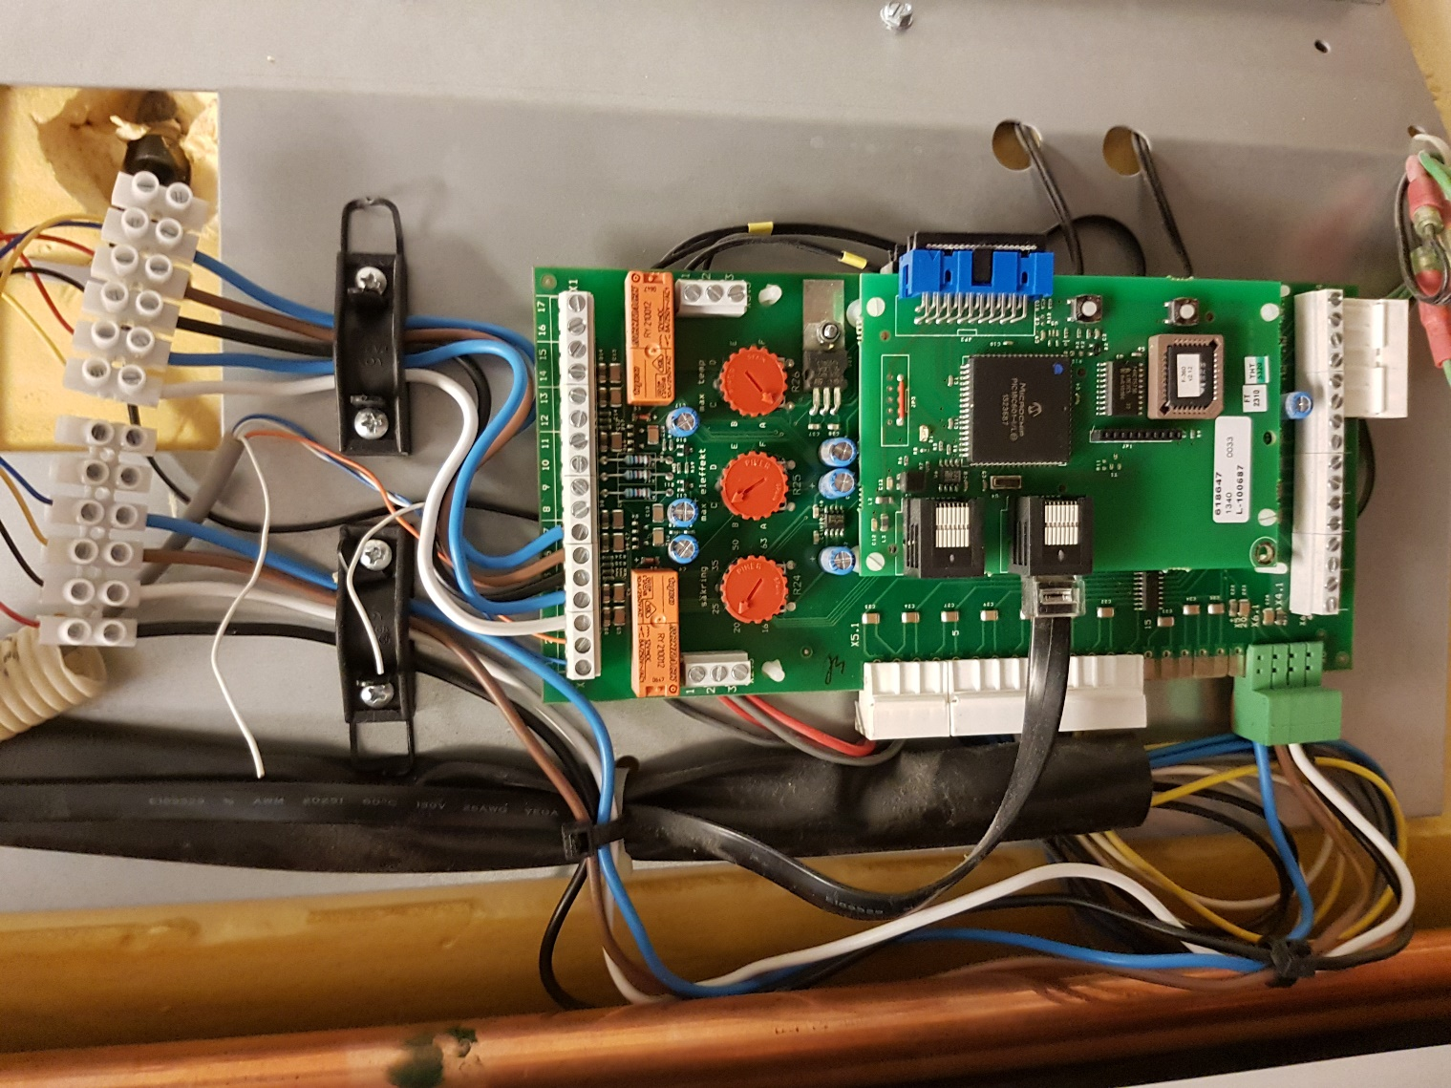

**Note 5:** Z-wave controller and relay board installed in the din-rail box.

